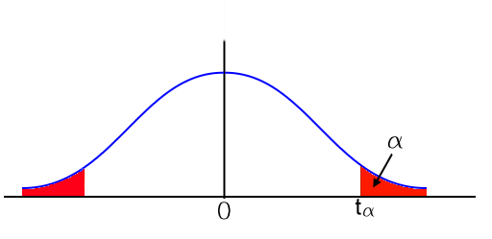
自由度df | t0.1 | t0.05 | t0.025 | t0.01 | t0.005
1 | 3.078 | 6.314 | 12.706 | 31.821 | 63.656
2 | 1.886 | 2.920 | 4.303 | 6.965 | 9.925
3 | 1.638 | 2.353 | 3.182 | 4.541 | 5.841
4 | 1.533 | 2.132 | 2.776 | 3.747 | 4.604
5 | 1.476 | 2.015 | 2.571 | 3.365 | 4.032
6 | 1.440 | 1.943 | 2.447 | 3.143 | 3.707
7 | 1.415 | 1.895 | 2.365 | 2.998 | 3.499
8 | 1.397 | 1.860 | 2.306 | 2.896 | 3.355
9 | 1.383 | 1.833 | 2.262 | 2.821 | 3.250
10 | 1.372 | 1.812 | 2.228 | 2.764 | 3.169
11 | 1.363 | 1.796 | 2.201 | 2.718 | 3.106
12 | 1.356 | 1.782 | 2.179 | 2.681 | 3.055
13 | 1.350 | 1.771 | 2.160 | 2.650 | 3.012
14 | 1.345 | 1.761 | 2.145 | 2.624 | 2.977
15 | 1.341 | 1.753 | 2.131 | 2.602 | 2.947
16 | 1.337 | 1.746 | 2.120 | 2.583 | 2.921
17 | 1.333 | 1.740 | 2.110 | 2.567 | 2.898
18 | 1.330 | 1.734 | 2.101 | 2.552 | 2.878
19 | 1.328 | 1.729 | 2.093 | 2.539 | 2.861
20 | 1.325 | 1.725 | 2.086 | 2.528 | 2.845
21 | 1.323 | 1.721 | 2.080 | 2.518 | 2.831
22 | 1.321 | 1.717 | 2.074 | 2.508 | 2.819
23 | 1.319 | 1.714 | 2.069 | 2.500 | 2.807
24 | 1.318 | 1.711 | 2.064 | 2.492 | 2.797
25 | 1.316 | 1.708 | 2.060 | 2.485 | 2.787
26 | 1.315 | 1.706 | 2.056 | 2.479 | 2.779
27 | 1.314 | 1.703 | 2.052 | 2.473 | 2.771
28 | 1.313 | 1.701 | 2.048 | 2.467 | 2.763
29 | 1.311 | 1.699 | 2.045 | 2.462 | 2.756
30 | 1.310 | 1.697 | 2.042 | 2.457 | 2.750
31 | 1.309 | 1.696 | 2.040 | 2.453 | 2.744
32 | 1.309 | 1.694 | 2.037 | 2.449 | 2.738
33 | 1.308 | 1.692 | 2.035 | 2.445 | 2.733
34 | 1.307 | 1.691 | 2.032 | 2.441 | 2.728
35 | 1.306 | 1.690 | 2.030 | 2.438 | 2.724
36 | 1.306 | 1.688 | 2.028 | 2.434 | 2.719
37 | 1.305 | 1.687 | 2.026 | 2.431 | 2.715
38 | 1.304 | 1.686 | 2.024 | 2.429 | 2.712
39 | 1.304 | 1.685 | 2.023 | 2.426 | 2.708
40 | 1.303 | 1.684 | 2.021 | 2.423 | 2.704

